Elephant Fact

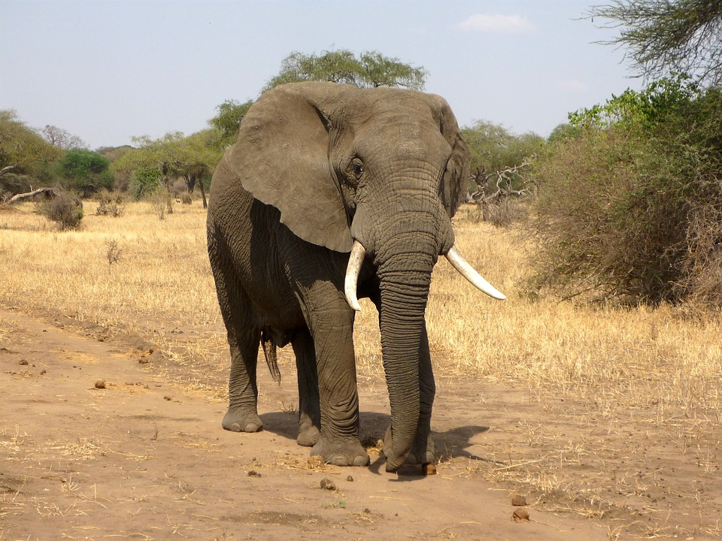**1)** There are three different species of elephant – the **African Savannah elephant**, the **African Forest elephant**and the **Asian elephant**. Elephants are known for their **large ears**, **tusks made of ivory**and their **trunks**.

**2)** Elephants are the world’s largest land animal! Male African elephants can reach **3m tall** and weigh between**4,000 -7,500kg**. Asian elephants are slightly smaller, reaching **2.7m tall** and weighing **3,000– 6,000kg**.

**3)** There’s an easy way to tell the African elephants apart from their Asian cousins – their ears! African elephants have large ears **shaped like the continent of Africa**! Asian elephants’ ears are smaller and **shaped like India**. Cool, huh?

**4)** You can tell a lot about an elephant by looking at their tusks! Elephant tusks **never stop growing**, so enormous tusks can be a sign of an old elephant. Both male and female African elephants grow tusks, but only **male Asian elephants**grow them. A tusk-less adult elephant is likely to be a female Asian elephant.

**5)** Until recently, African Forest elephants were thought to be a **subspecies**of the African elephant, but new research discovered that they are actually **a separate species**entirely**.** These elephants live in the tropical forests of **Africa’s Congo Basin.**They have straighter tusks and more rounded ears than Savannah elephants.

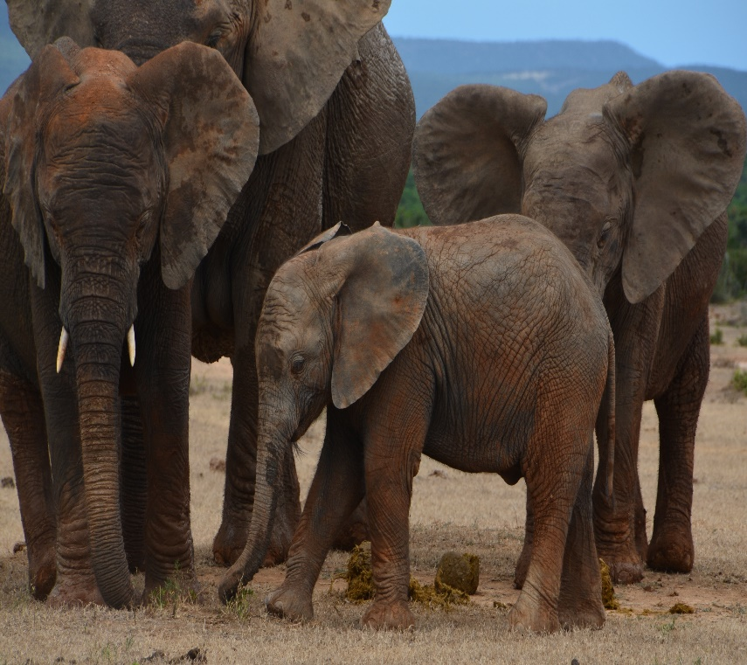**6)** These magnificent mammals spend between **12 to 18 hours**eating **grass**, **plants** and **fruit** every single day! They use their long trunks to smell their food and lift it up into their mouth – yum!

**7)** All that eating means one thing, gang, an awful lot of **poo**! Each elephant creates about one tonner of poo per week, which keeps the **soil fertile** and **disperses tree seeds**. Elephants also **dig**waterholes and **create footpaths**, literally changing the landscape around them!

**8)** In **Mount Elgon National Park**in [**Kenya**](https://www.natgeokids.com/uk/discover/geography/countries/country-fact-file-kenya/), a group of elephants use their tusks to mine for salt in **underground caves**! They feel their way around with their trunks and eat the salts by breaking them off with their tusks.

**9)** Elephants have created their very own **sunscreen**! After a river or swamp bath, they’ll throw mud and sand up and over themselves to protect their skin from the hot, burning sun. Clever!

**10)** Sadly, elephants are in trouble. Many are killed by humans for their **ivory** tusks, because they’ve come into conflict with communities or simply for sport. There are far fewer **Asian elephants** than there are **African elephants**. Asian elephants also face threats from **tourist attractions** where people pay to ride on their backs or watch them paint pictures using their trunks.